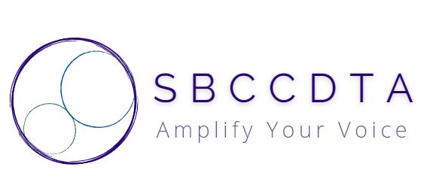
Amplifying the voices of fellow faculty to advocate for themselves by organizing and mentoring and defending and negotiating the contract.
Executive Board Meeting (9 am-12:30pm)

- Treasury Report (Jamie)

- Grievances (Leonard)

- Calendaring
  - Executive Board Meetings (Lunch Order/Pickup)
  - Adjunct Orientation Recruitment (CHC/SBVC)
  - SP 25 General Membership Meeting (SBVC)
  - Luncheons (CHC/SBVC)
  - Joint Meeting with CSEA
  - Joint Meeting with SBTA (4/23, 4:30pm, Offices)
  - CCA Winter Conference (2/7-2/9)
  - “Spring Fling”
  - PT Equity Dinner

- Swag
  - Order Swag
  - Receive Swag
  - Inventory Swag
  - Distribute Swag
  - Completion Metrics
  - Create Swag Subcommittee

- Communications
  - Purposes/Potentials/Pitfalls
  - Communications Shop Stipend
  - Streamline Outputs
  - Streamline Inputs
  - Website/Discord Operations (SP 25)
  - Recording/Uploading Minutes
  - Communications Manual

- SB 553
  - Define/Discuss Law
  - Anticipate Union Exposure
  - Plan E-Board Protocols
  - Outreach to DSO
  - Outreach to Members

- E-Board Officers’ Written Reports
  - Compile/Submit to President

