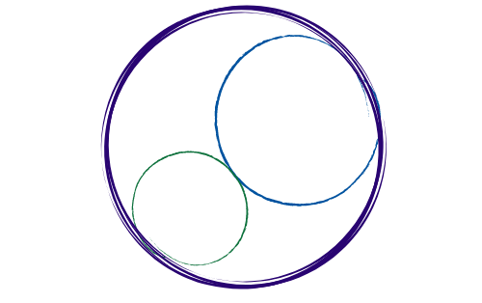September 20, 2024
12:00-2:30pm [Zoom]

SBCCDTA
Amplifying the voices of fellow faculty to advocate for themselves by organizing and mentoring and defending and negotiating the contract.
Action and Work Items
The following items need action from the executive board.

 | Action Item
President | - Discuss Chapter Bylaws Edits  - Outline Agenda for 10/2 General Membership meeting
Elections/PAC | - Mechanics of Bylaws Vote  - ABC Grant Status
Secretary | - Alert General Membership about October 2nd meeting  - Prepare Meeting Minutes (9/6 and 9/20)
Treasurer/Negotiations | - PAC Contribution Status  - PT Software License Access  - Negotiations Update
VP (CHC/SBVC) | - Reserve General Membership meeting space (CHC)  - Publicize General Membership meeting
FT Reps (CHC/SBVC) | - Publicize General Membership meeting  - Allied Health Associate Dean (SBVC)
PT Reps (CHC/SBVC) | - Publicize General Membership meeting  - PT Recognition Activities/Outreach

